RIVER BLADNOCH DISTRICT SALMON FISHERY BOARD

MINUTES

of Meeting of the River Bladnoch District Salmon Fishery Board

held by Zoom
At 5.00pm on Tuesday 12th October 2021
_______________

Board Members Present
Colin Richardson (Chairman)
Jonathan Haley
Mark Davies
Chris Hockley
David Pagan
Andrew Gladstone

Also in Attendance
Peter Matthews (Clerk)
Jamie Ribbens (GFT)
Karl Munday (NatureScot)

1. The Chairman opened the meeting at 5.00pm and welcomed those present.
Apologies were recorded from:-
Sir Michael Wigan, Dick Scott, Mark Godfrey and Charlie McNeil

2. Declaration of Interest

For the benefit of those attending the first meeting (Karl Munday and Peter Matthews) members of the Board introduced themselves and having had an opportunity of considering the Agenda no conflict of interests were declared

3. Minutes
Minutes of the meeting of 6th April had been circulated and adjusted. Adoption of the Minutes as adjusted was proposed by Jon Haley and seconded by Chris Hockley. The meeting was reminded of the Board’s obligation to publish its Minutes and the Board were authorised to publish on the GFT Website.

4. Matters Arising Therefrom

The Chairman indicated that most of the Matters arising would be dealt with on the present Agenda and only the following items required discussion.

(a). Levy on the Netting at Garlieston

The Board’s policy in the past had been not to charge a levy on the nets at Garlieston so long as the nettings were not used. The Board agreed to continue with that practice and no payment would be requested.

(b) Repair to the Lade at Bladnoch Distillery

Jon Haley reported that there had been a repair to the damaged Lade which appeared to have improved the position and it would be monitored.

5. Insurance

The Board’s annual insurance covering its activities was arranged through brokers Lycetts each year. A concern was raised that the annual premium was high in comparison to the premium paid by the neighbouring Board. The meeting considered that the Board’s insurance requirements should be reviewed to ensure that they accurately reflected the Board’s activities and the risks that required to be covered. It was agreed that Mark Davies should liaise with the Clerk with a view to determining the Board’s insurance requirements and contacting brokers to see if the annual premium could be reduced. Mr Davies would duly report to the Board with his findings prior to the next renewal date which would be August 2022.

6. Board’s Financial Position

The Clerk reported that some disruption had been experienced in ingathering levies partly due to the business disruption caused by the Covid outbreak; the Clerk had reported that ingathering of Levies was now satisfactory and as at the end of August funds of just under £8,500 were held. Annual notices had in fact been sent out a little in advance and certain members’ advance payments would be transferred to the 2022 Season; certain members had actually paid for that season twice and would be refunded.

7. Hatchery 2021

The Chairman reported that in recent years the Board had obtained a licence from Marine Scotland to stock the river. It was noted however that for the current year there was a significant lack of fish and a decision was made not to apply for the licence this year. Marine Scotland had been advised of the Board’s decision and the reasons for it.

8. GFT Report

Jamie Ribbens was asked to give the GFT Report and confirmed the Chairman’s earlier remarks that the current season had been extremely poor due to the prolonged dry spell in the summer and a significant lack of fish. The Bladnoch was not the only river to suffer. Mr Ribbens had circulated his Report to the Board members in advance of the meeting and spoke to it at length. The Report is attached and adopted into these Minutes.

9. Catch Returns 2020

The Chairman reported that the Clerk had obtained the Bladnoch catch data for the 2020 Season in June this year, from Marine Scotland and this had been forwarded to the Board Members. Due to the results the Bladnoch was a Category 2 River for the 2022 Season this Category however would be affected by the poor 2021 Season. It was also suggested that for the 2020 Season some Beats may have underreported and proprietors should be encouraged to report accurately in future.

10. Season 20/21

As had already been noted the 20/21 Season was exceptionally poor for the reasons discussed it was however noted that the Bladnoch was not the only river in Scotland to suffer.

11. AGM

The Chairman reported that the Board required to hold an Annual General Meeting every year and proposed to hold this in November. The Agenda would be the Chairman’s comments, the Financial Position, the Galloway Fisheries Trust Report and any other competent business. It was proposed to hold a live meeting in the Bruce Hotel if possible. The Clerk was instructed to approach this Hotel to establish whether its large meeting room would be available sometime in the last two weeks of November and liaise with the Chairman in order to fix a time and date. It was proposed the meeting should commence slightly later in the evening to attract other attendees.
12. A.O.C.B

Jamie Ribbens advised the meeting of a current report that Bladnoch Smolt had been recorded going through the Minch. It was encouraging that the Smolt appeared to be travelling north although the numbers were not yet available.

There being no other comments or competent business the meeting closed at 6.20pm with a vote of thanks to the Chairman.

Summary of recent GFT work on the Bladnoch catchment (12/10/21)
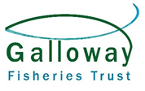
- Smolt tracking work

The River Bladnoch is part of the Atlantic Salmon Trust ‘West Coast Tracking Project’. GFT tagged 133 large salmon smolts trapped in the fyke net at Torhouse Trout Farm. Four instream receivers were present from the fish farm down to Wigtown Harbour to follow their movements in the lower river. The overall project has various receiver arrays at sea to pick up the smolt migration routes.
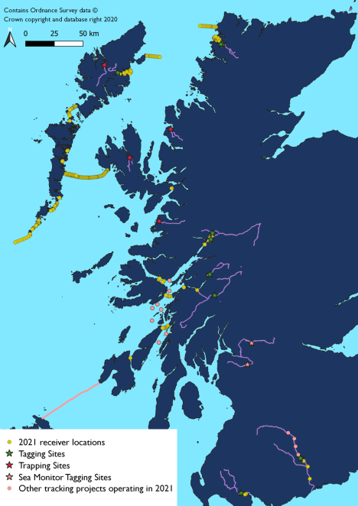
- Water Quality Monitoring
GFT collects a range of water quality from the Bladnoch catchment annually both through spot sampling and continuous monitoring. This work is focussed on the winter / spring and pH levels. The data is written into a report and submitted to SNH / Peatland Action in the last few years. This work includes collecting pre-peatland restoration data for Tannylaggie Flow.
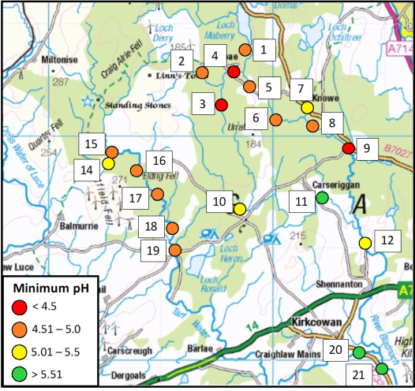
- Kirkcowan Fishing Competition
An impressive 31 adults and 11 juveniles attended. No buffet offered this year and it was held at the old football field. Thank you to everyone who helped to organise it.

- Bladnoch Distillery
The large leak in the lade was fixed by the Distillery in mid April. GFT visited the site a few times during the very low flows late spring / summer to check on levels etc. Additional measures were put in place to reduce any water going down lade when possible. GFT are working with the Distillery / SEPA to understand impact of abstraction at various low flow scenarios in 2021/2022.
- Polbae Burn Denil Fish Pass
A recent inspection by GFT of the fish ladder found it blocked and impassable to salmon / trout. It has now been cleared. We have also spoken with the new owners of Polbae House who will inform us if it blocks again.
- Forest Plans and consultations
GFT have recently input to two forestry restructuring plans; Shennock Forest (borders the Black Burn) and Kilgallioch Forest (covering upper Tarf Water and Pulganny Burn). GFT raised concerns about any replanting Sitka on peat, highlighted peatland restoration opportunities and requested new riparian deciduous tree planting targeted at addressing predicted water temperature rises.
Artfield Forest Wind Farm proposal - consultation response submitted.
- 2021 Electrofishing Survey
Electrofishing confirmed successful salmon spawning in the Loch Strand Burn following the habitat restoration works. These are the first wild salmon fry GFT have found in the burn. This supports the evidence that salmon continue to recover in the upper Tarf (> 5 km recovery in the main stem Tarf in last decade).
The stocked sites around the Loch Strand outflow, other nearby burns and the main Tarf all had healthy numbers of salmon fry present.
Further electrofishing completed on the Barquhill Burn (small burn containing trout only), Tarf Water (by Mark of Luce Farm – good numbers of juvenile salmon), Barhoise Burn (lower reaches – decent numbers of juvenile salmon / trout), upper Drumpail Burn (contained salmon from stocking programme), lower Polbae Burn (few trout parr only) and Black Burn (upstream of Drumabrennan – mostly trout fry but a few salmon fry and parr).
We also sampled salmon fry for genetics at Black Burn, Tarf (at Tarf Bridge), mid Barhoise Burn, Bladnoch near spittal and Tarf below Thomas Dam. This study (funded by SNH) is looking at whether Carradale farmed salmon escapees bred with wild salmon last winter. Also all salmon parr caught at NEPS sites are sampled to check for genetic evidence of fish farm escapees.
GFT electrofished on the Barhoise Burn between the B735 road bridge and the old railway line and found it devoid of salmon / trout. This area usually supports a lot of fish but must have got very low during the summer. Were there a lot of cows in the field maybe as burn is accessible?
- Habitat Works / Invasive plant control
Phil surveyed 15 water courses or river sections as part of his Priority Salmon Habitat Restoration Project. The Loch Strand Burn restoration works were part of this project. Various discussions with forestry interests have also taken place. GFT have recently secured further funding from SNH for habitat works (which includes the Bladnoch catchment) to be spent before March 2022 with a focus on making water courses more resilient to climate change impacts and reduce pollution. The works are to be directed by the Phil’s surveys.
Skunk Cabbage plants were sprayed in a garden / drain near Glassoch to stop them reaching the main river.
National Adult Salmon Sampling project (ASSESS)
There is a Marine Scotland Science project this autumn to collect accurate weights, lengths and scale samples from returning adult salmon. Due to low water / high water temperatures GFT did not collect any data from the Bladnoch.

